Practical 7: Queue Implementation using Array and Linked List, with Structure Simulation
Problem 1
A government office has a token counter that issues tokens to visitors. The counter can hold at most n tokens at a time. New visitors join from one end and are served from the other end in the order they arrived. If the counter is full, no new token can be issued, and if it is empty, no one can be served. Given a sequence of join and serve operations, implement this fixed-capacity token queue and print the current front token after each operation. Report an error if a join or serve operation cannot be performed.
Describe how your solution tracks the front and rear of the queue. What happens when the queue becomes full, and what does your solution do when a serve operation is requested on an empty queue?
Code
https://github.com/AD-9218/DATA-STRUCUTURE-AND-ALGORITHM/blob/main/Practical-7/7_1.cpp
Output
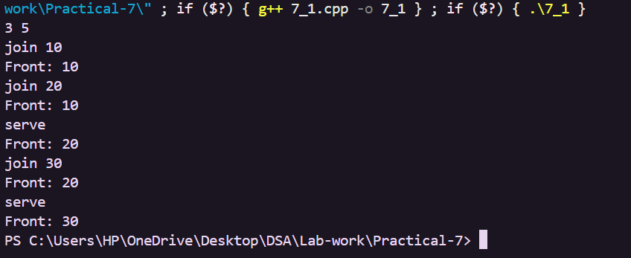
Problem 2
A hospital emergency ward receives patients continuously and attends to them strictly in the
order they arrived, with no upper limit on how many can be waiting at once. New patients are
added at the back and the doctor always attends to the patient at the front. Given a sequence of
arrive and attend operations, implement this unlimited patient queue and print the current front
patient after each operation.
Describe how your solution differs from Problem 1 in how it manages capacity. What happens in
your solution when the attend operation is called on an empty ward with no patients waiting?
Code
https://github.com/AD-9218/DATA-STRUCUTURE-AND-ALGORITHM/blob/main/Practical-7/7_2.cpp

Output
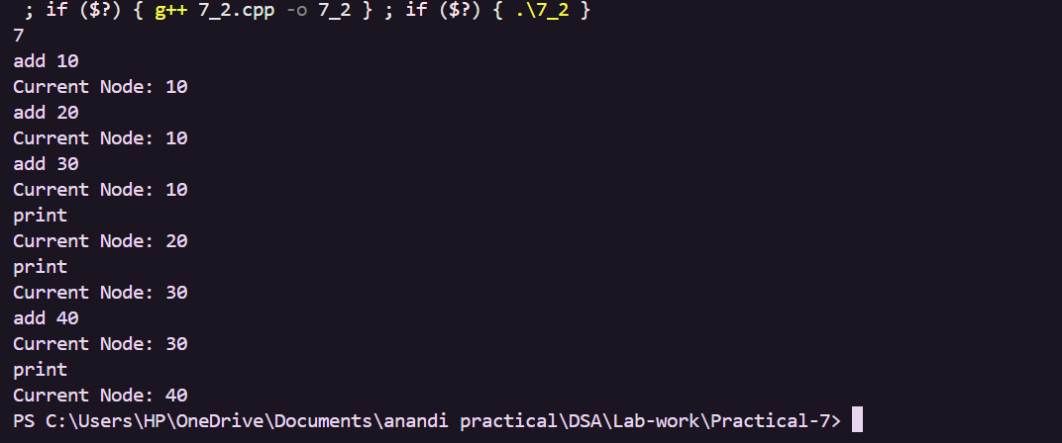
Key Questions / Analysis / Interpretation
1. [Problem 1] A circular array is one way to reuse freed slots without shifting all elements. Without implementing it, explain what change would need to be made to your front and rear pointer logic to make the array behave circularly, and what new condition would indicate a full array.
Answer: The front and rear positions should move using modulo n so that they wrap back to the first slot. A separate count variable can indicate that the circular queue is full when count equals n.
2. [Problem 2] Your linked-list queue has no fixed capacity limit. But in practice, can it still run out of space? Explain why this can happen and what determines the practical limit.
Answer: Yes, it can still run out of memory because the system has limited memory. Every newly created node uses memory, so the practical limit depends on the amount of memory available to the program.
3. [Problem 3] Suppose a printer queue used a stack instead of a queue. How would the order of jobs change, and why would that differ from normal first-come-first-served processing?
Answer: A stack follows LIFO (Last In, First Out), so the most recently added job would be processed first. A queue follows FIFO (First In, First Out), so the earliest arriving job is processed first.

